HURRICANE INSTALLATION GUIDE
Step 1 :Setup Bluetooth Software
- First,installBluesoleilprogram on your computer.Select theinstallation languageandclickNext
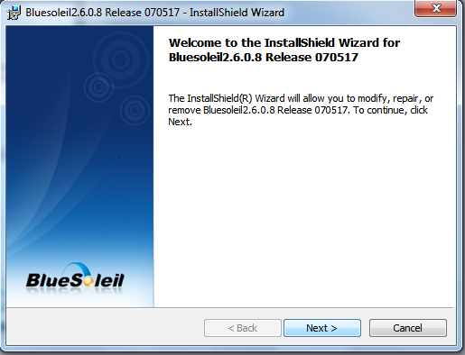
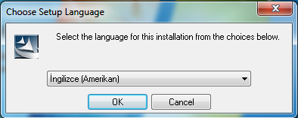

- ClickFinish whenthe installationfinished. And thebluetoothdeviceinto your computer.
Step 2 :Computer with Device Bluetooth Connection
- Turn on hurricane X-3 Ultra
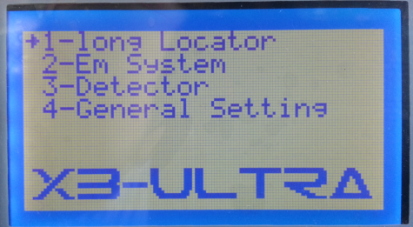

- Now, turn onyour computer,bluesoleilprogram.Please turn before the program BlueSoleil.In the program, click View. And later on, please click the refresh device.The following screen will like the device. Double-click the device, click the name (CONRAD X-3 ULTRA)
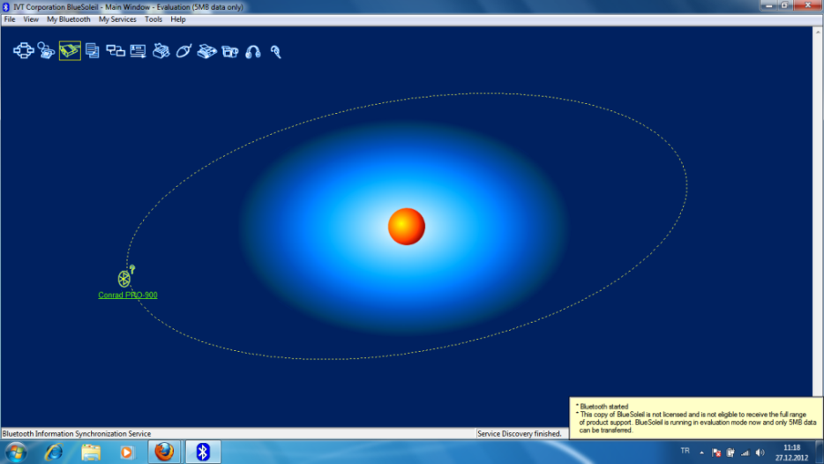

- Thenintothe yellow frameon top, please click theBluetoothserial portservice.
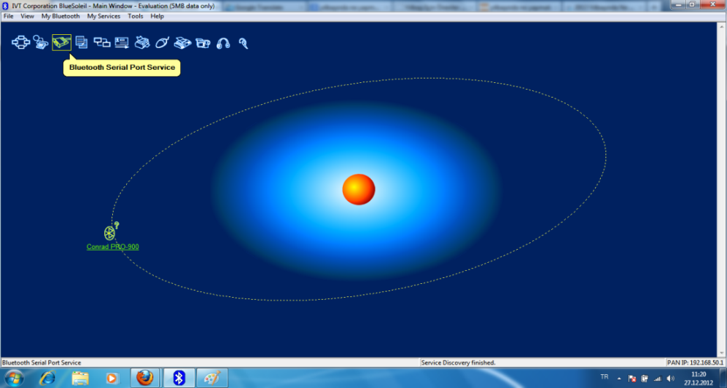

- As shown below, the program will writecount ofthatport.
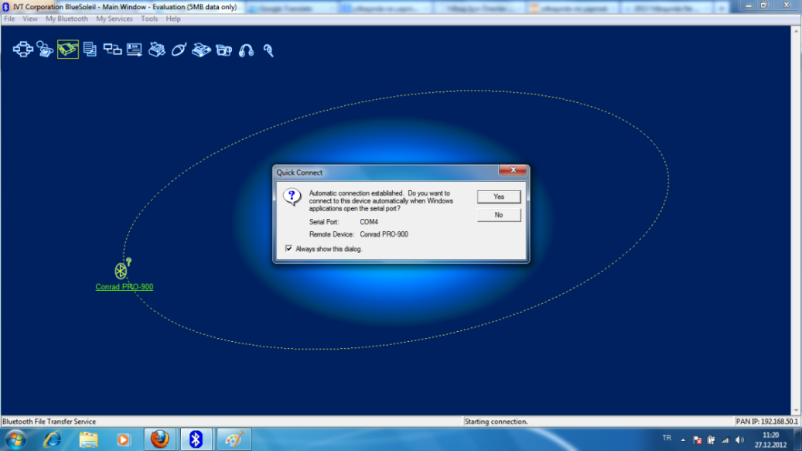

- YesClick hereandaskfor a password. Passwordis ‘ 1000 ‘
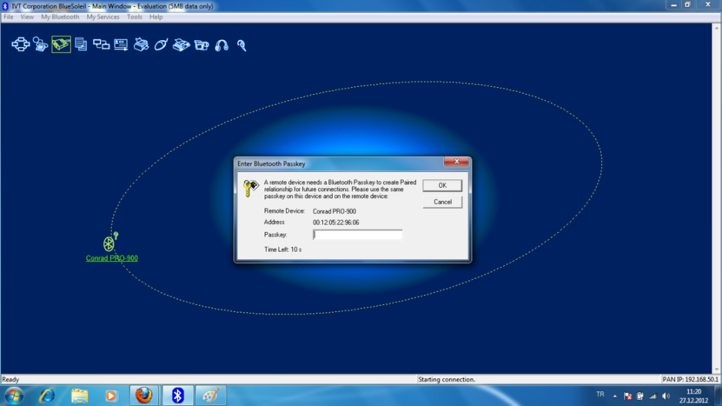

- And finally,the connection is establishedthe connectionwill turn green.
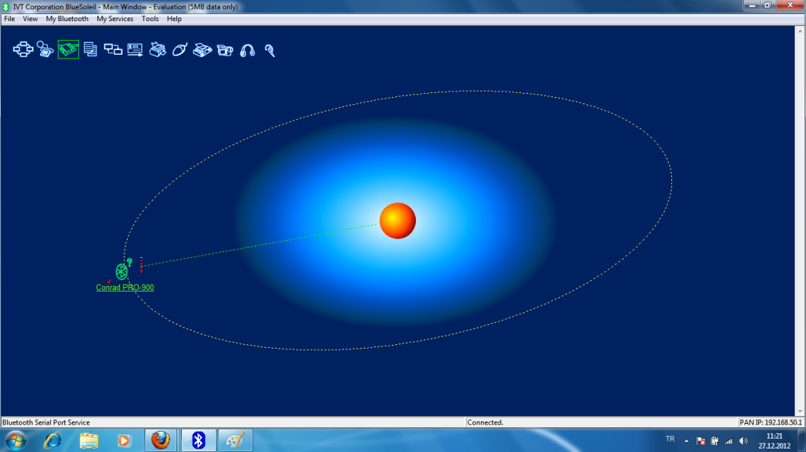

Step 3 : Graphicsand data transfer
- Open the 3D groundMonitoring Program. Open a newproject in the File tab.

- If you want to search the manual or automatican deep, as the choice of the device 3D IMAGER click Select. Then, select the connection port toyour. Connection mode (bluetooth). And then select the number of the signal to each well.However, not click on OK. Pleasewait in thisway.
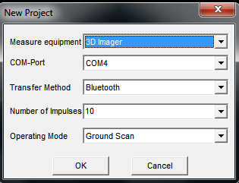

- Thedevice's main menu, select 2-EM System.

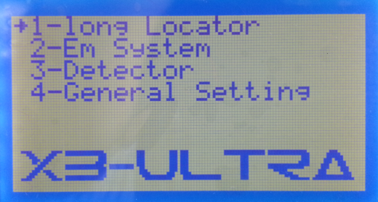

- To make the setting for the image transfer section, enter Device &Setting.
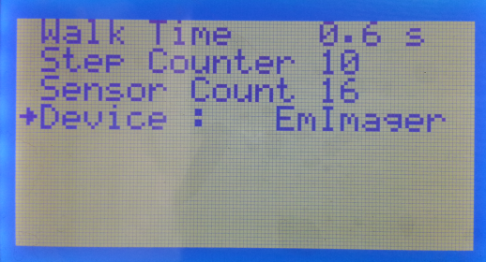
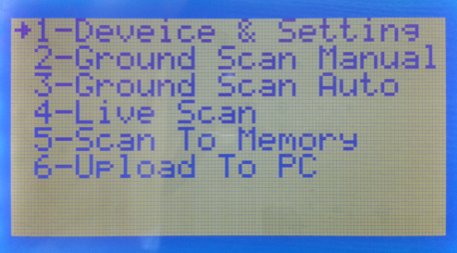

- WalkTime : You can adjustthesignalsending time in automaticscans.
- Step Counter :You can adjustthesignalcountto be sent foreveryscanningline.
- Sensor Count : Standart sensor count 16.
- Device :If youwant to makethe standard3Ddata transfer, thenselect EMImager.
Ifyouwanttoliveultrasonicdata transfer, select EM Ultra.
- After you select the data transfer mode, EM System menu to select Manual or Auto Select.
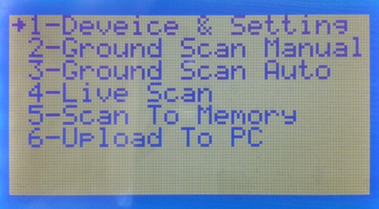

- After making the selection, press the OK button. Press the OK button again. Again, press the OK button, and the device main screen NOW PRESS START Repeating the wait.
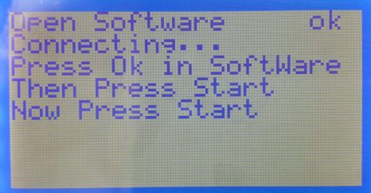
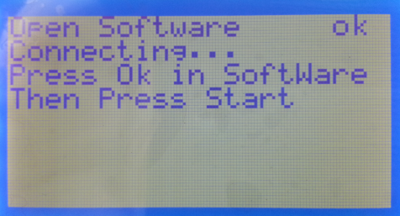
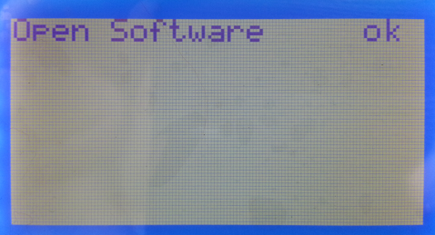

- Now, the computer program, press the OK button. Then, the X-3 Ultra device, press the START key.

Thus, began the transfer of data and graphics. The same process is applied manually or automatic all scans.

Touse the Live Scan, follow the steps below.

1 - Select the EM System press OK
2 - Select Device &Setting press OK
3 - Device: select EM Ultra and press return.
4 - Select Live Scan press OK
5 – Press the OK button. Press the OK button again. Again, press the OK button, and the device main screen NOW PRESS START Repeating the wait.
6 – The computer program as equipment UltraSound 's Select. Operating Mode Live Scan (HorizantalProbe ) ‘s Select , Select a port to your connection and press OK. Then, the X-3 Ultra device, pressthe START key.

3D Software ButtonsandFunctions
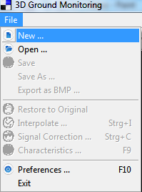
F
New Project to open and allows you to make settings

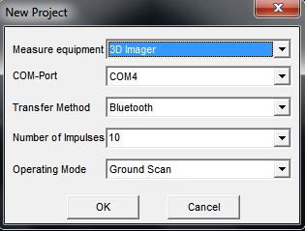
Part of the new project, the working mode of the connection port to your choose.

C

New Project
Open the saved Project
Save a Project
Graph sharpening
Cavity, Metal and Earth data removing

The graph is used for the calculation of the size. Each frame is equalto 30 cm.
Revert to original graph.
Depth line to move
Interpolate: improve the quality of graphics. If you haveany metal in search data, interpolate using the key distinction can be artificial or natural.
Interpolate the value of theuse of 3.
Utilities to fix faulty signals. Ruler 7/4 should be used.

Enlarge and shrink the size of graphic works.

d
Helps you choose the type of soil.

F6 Cavity data clearer. F5 takes you back this query. F7 Metal data clearer. F8 toget back to this data.

Allows you to move the chart

